FOUNDATION FOR VIRTUAL AND AUGMENTED REALITY SYSTEMS
Lecture28
Lec-28: Visual Perception & Displays II
Hello and welcome to the NPTEL MOOCs course on Foundations for Virtual and Augmented Reality Systems. We are going to continue our discussion on visual perception and displays. So, in the previous part of the lecture, we talked about the physiology of vision and how we visually perceive, how the light comes to our eyes, what happens with that light, and how it is carried to the brain. In this lecture, we are going to continue our discussion; we are going to learn about how this knowledge that we have acquired in the previous part of the lecture,
how it is going to help us understand the working of head-mounted displays and other kinds of displays that we typically associate with immersive experiences. So, let us try to put whatever we have learned so far, put everything together, and try to understand how the headsets work. That is the most prevalent and easily associated form of displays that we think of while thinking of immersive experiences. So, when we talk of human eyes, then whatever we have gathered so far, based on that, what we can say is that
An eye looks something like this, as shown in this figure. So, it shows a cross-section of the human eye facing the left direction. Now, the light rays are falling on it. They can be assumed to be, we can assume them to be, parallel light rays entering from the left side. Then we have the cornea.
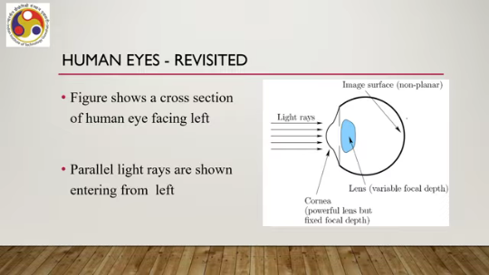
which in itself can be considered to be a powerful lens, but having a fixed focal depth. We have the lens, the human lens, a natural lens with variable focal depth, and the retina, the image surface or the portion of the eye where the light rays fall and then gets transmitted to the brain through optical nerves. Now, this is what we can call the image surface, which is a non-planar surface as you can see from the diagram. Now, that is the natural human eye.
Now, let us consider an engineered lens setup. So, this is the engineered lens, that is, an artificially created lens, with parallel lights coming from the left side. They are converging to a focal point which is on the focal plane, and the distance between the lens and the focal point is the focal depth. Try to understand this concept with respect to the natural human eye shown here. So, what are the differences between the natural human eye and the engineered lens setup?
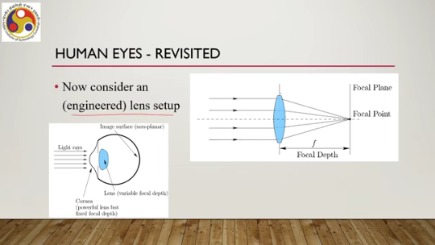
There can be a few differences that we can highlight. One is the focal plane is replaced by the retina. When we are transitioning from, when we are comparing the human eye with engineered planes, we can say that the focal plane is replaced by the retina. So, in the case of a human eye, there is no focal plane as such, but there is a non-planar retina which replaces the concept of a focal plane; that is, a spherically curved surface.
Now, the retina contains photoreceptors that convert light into neural pulses. A similar thing is not there in an engineered lens. The interior of the eyeball is actually liquid as opposed to air through which light passes in the case of an engineered lens. So, in the case of an engineered lens, light falls on the lens and then passes through air to reach the focal plane, whereas, in the case of the human eye, there is no air inside the eye, rather a liquid through which the light passes after
Getting transmitted through the lens. A ray of light travels through five media before hitting the retina in the case of the human eye. Now the idea is illustrated here: we have first air through which the light comes, then cornea. Then one liquid, then lens, then another liquid. So, five different media, and each is having its own refractive index, that means the amount of light that passes through, which determines the amount of light that passes through the medium.
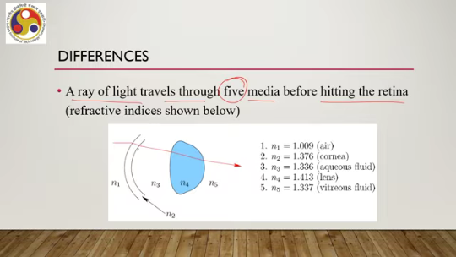
Air 1.009, that is the refractive index; then cornea, 1.376 refractive index. Aqueous fluid, this part, liquid-type material, 1.336. Natural lens, N4, 1.413. And finally, another liquid, vitreous fluid, 1.337. So, light passes through all these five mediums, five media.
With different refractive indices before it reaches the retina, which is not the case with an artificial or engineered lens setup. So, if we try to understand the normal eye operation, let us see what happens. So, outer diameter of the eyeball is approximately 24 millimeters, implies that a lens of at least 40 diopters are required to cause the convergence of parallel rays onto the retina center. So, light is coming in this way, and to converge it to the retina center, that is the focal point; we can roughly call it the focal point.
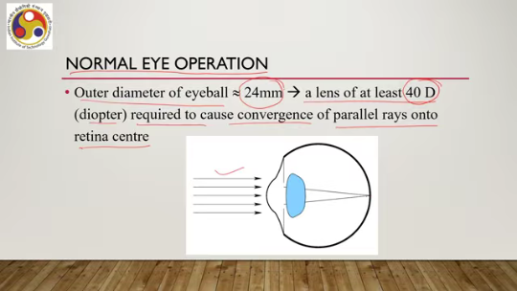
We require a lens of at least 40 diopter if we are thinking of a single lens. But in the case of our eyes, there are effectively two convex lenses: the cornea and the lens. So, the cornea can be considered as a lens, a type of lens, and the lens is, of course, a lens. Then we have to combine their diopters to see whether it matches the required 40-D power of the lens. So, cornea optical power is 40 D, approximately 40 diopter, and the eye lens is less powerful, approximately 20 diopter; that is well known.
So, when we combine these two lenses, then their combined power of cornea and natural lens is 60 diopter, which is more than what we require when we are talking of a normal eye. So, since the combined power of the system is more than 40 diopter, images of faraway objects are therefore focused onto the retina because of this combination, cornea and lens. So, generally, with a normal eye, there is no issue with that. Now, what happens with a VR headset? Suppose we are constructing a VR headset by placing a screen very close to the eyes.
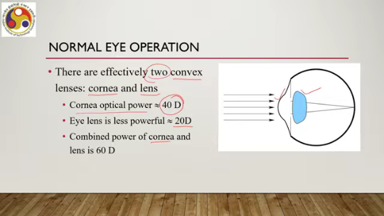
Now, what do we want? We want to bring it close so that it fills the view of the user. The user is not able to see anything beyond the screen. The optical power is increased by using a convex lens functioning in the same way as reading glasses. So, inside the VR headset, there will be a convex lens plus a screen that will
render the image and the lens will help us focus it to the retina. So, this is the VR headset engineered lens setup where we have the screen, we have the engineered lens, and the light from the screen passes through the engineered lens then falls on our eye, and then normal eye operation takes over. And the distance between the screen and the engineered lens should be the focal distance of the engineered lens to get the best experience. So, to get the best experience, the engineered lens that is part of the VR headset is usually placed at the distance of its focal length.
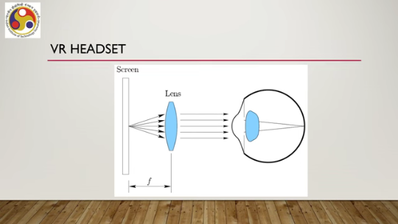
The screen appears as an enormous virtual image that is infinitely far away. If we follow the first condition, then the second condition will be followed. It may be noted, however, that a real image is nevertheless projected onto the retina. We do not perceive the world around us unless real images are formed on our retina. So, here, our objective is to make the artificial system comprising the screen and the engineered lens that is part of the headset or any other display,
work in a way such that it converts the light into normal light that falls on the eye so that eventually we get to perceive the image of whatever we are seeing, After it falls, the light rays fall on our retina. So, essentially we are supplementing our normal eye operation with a special setup that utilizes the normal eye operation. So, then how do we perceive the depth or three-dimensional properties of objects? How do we do that?
One important concept here is the field of view. That is the region visible to the human eye. It is an angular measure of what can be seen at a single point in time. So, if this is the eye, this entire frustum, the view frustum refers to the field of view. So, the human eye has approximately
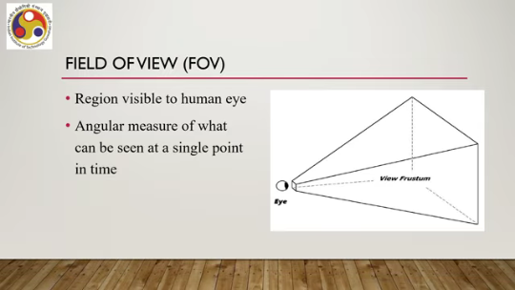
a 180-degree horizontal field of view as shown here. So, if these are the lens eyes, then we have a 180-degree field of view horizontally, and vertically we have a 150-degree field of view. So, within this range, we can see things, and horizontally, within 180 degrees, we can see things utilizing both our central and peripheral vision. So, horizontal FOV is 180 degrees, vertical FOV is 150 degrees. Now, when we are looking at something using both our eyes, both eyes can see the same area over an angle of about 120 degrees when focusing on infinity.
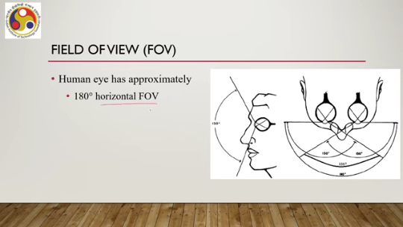
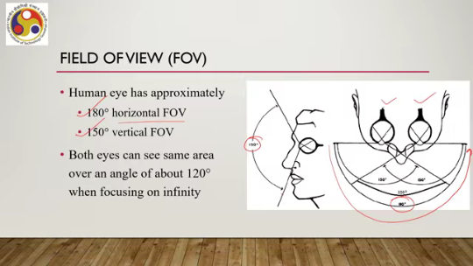
So, this 120-degree region denoted by this region, is a common region where both eyes get to see the same thing. Otherwise, outside this region, this part is seen only by the left eye, and this part is seen only by the right eye. So, this is called binocular vision. This common 120-degree area: both eyes are used to see the same image within this region.
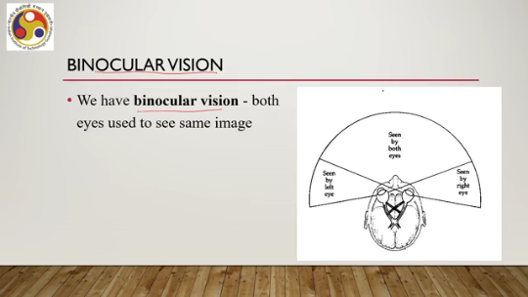
Outside this region, some parts are seen only by the left eye, whereas some other parts are seen only by the right eye. Now, this binocular vision enhances depth perception and the relationship between objects in 3D space. So, it helps us understand the relationship between objects in 3D space, as well as enhances our depth perception. This brings us to the related concept of stereoscopy. So, we use two eyes to view two images simultaneously, some parts of which may be overlapping due to the common region in our field of view.
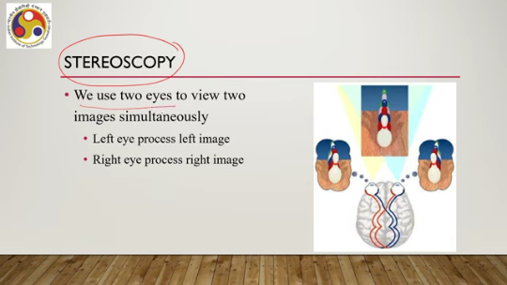
The left eye processes the left image; the right eye processes the right image. So, this is the left eye, this is the right eye; the left eye sees this one, the right eye sees this one. There is a common part which both eyes see and some parts which only one eye sees. So, in this context, maybe this part is seen only by the right eye, whereas this part is seen only by the left eye. Now, these two 2D images, each for one eye, when they get processed simultaneously, that processing generates a 3D view of the objects.
So, stereoscopic vision essentially helps us perceive a 3D view of the object, which is aided by our binocular vision property. That is about perceiving 3D. Now, let us try to understand how we perceive motion or the perception of movement. So, a virtual world may allow up to two types of movements in 3D space: translational, which is used for navigating in the 3D space, and rotational, which is primarily used for moving at different angles along the translational axis.
So, broadly these two types of motions can be there in any virtual world and how we can perceive them. Now, there is this concept of degrees of freedom which is an indication of the different ways an object can move in space. So, there can be a total of 6 degrees of freedom in 3D space. There are 3 rotational degrees of freedom which are called yaw, roll, and pitch and 3 translational degrees of freedom along the x, y, and z axis. So, in this small animation, you can see the
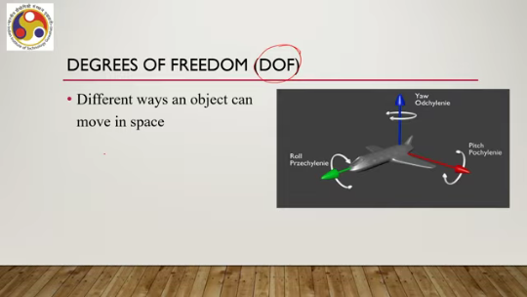
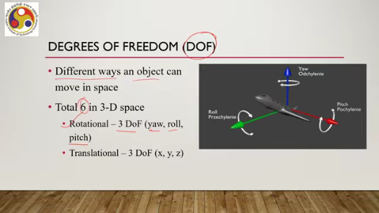
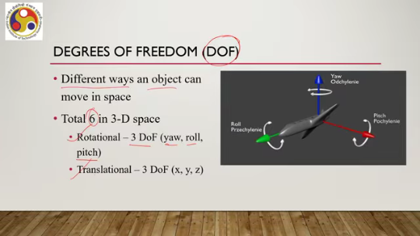
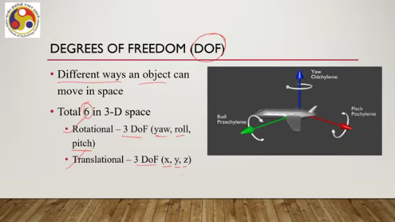
Yaw, roll, and pitch things. This is the roll part; this is the pitch part. So, this is the roll part, the pitch part, and this is the yaw part. Then we also have the translational degrees of freedom: 3 degrees of freedom along the 3 axes, x, y and z axis.
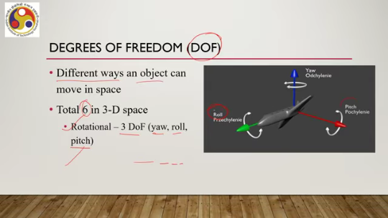
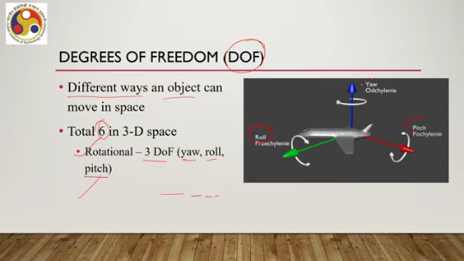
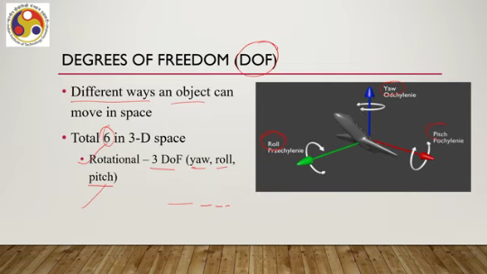
So, we perceive motion with respect to the degrees of freedom whatever is supported. Now, what are the issues here? What does this knowledge that we have acquired so far tell us? So, basic physiological properties such as photoreceptor density can directly impact engineering requirements for visual display hardware. So, the way we design the hardware can be determined based on the kind of
photoreceptor density. So the displays are generally designed based on that knowledge. Engineered systems must be good enough to adequately fool our senses. So our brain perceives in a way that has been learned over generations. When we are trying to perceive things differently, that engineered system must be
good enough to fool our natural way of perception, but need not have levels of quality beyond the limits of our receptors. So, we should know how much our brain, our system, our body can process and how much it cannot. So, accordingly we should design the system. VR displays should ideally be designed to perfectly match the performance of the sense they are trying to fool, in this case the visual sense. So, in order to achieve that, what are the important considerations?
Spatial resolution, that is how many pixels per square area are needed, is one consideration. Then intensity resolution and range. How many intensity values can be produced and what are the minimum and maximum intensity values on the basis of our knowledge about, how many such values can be processed without compromising our perceptual quality. And thirdly, temporal resolution, that is how fast displays need to change their pixels.
In other words, frame rates. Or refreshing, frame rates are very important, particularly in the context of motion perception. We need to understand how objects are moving. So, which frame rates allow us to perceive motion smoothly without any jitter? Let us try to understand spatial resolution, what studies tell us, and how it can be useful.
So, we see individual lights when a display is highly magnified. As it is zoomed out, we may still perceive a sharp diagonal line as being jagged, known as aliasing. Say for example here, the more we zoom out, the more we get to see this type of aliasing effects. Instead of smooth lines, we get to see
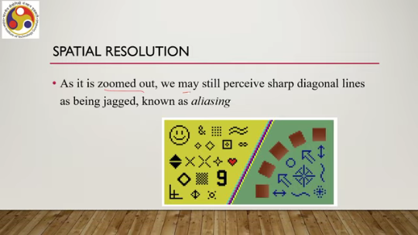
some staircases, jagged lines that are called aliasing. Everywhere we can see that. Similarly, there can be other effects. One important effect is called the screen door effect. It is commonly noticed in images produced by LCD projectors as you can see here.
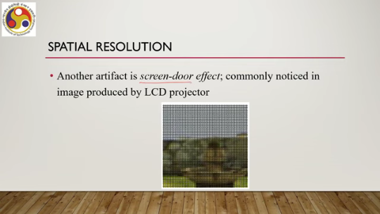
It appears as if there is a screen. on top of the image because of this zooming thing. So, the question is what kind of resolution we should support so that these types of effects are not visible even if we are zooming in or zooming out the image. So, what does the display pixel density need to be so that we do not perceive individual pixels or these aliasing effects? Now, there is a concept called retina display.
In 2010, Steve Jobs, probably all of you have heard of him, from Apple, claimed that 326 pixels per linear inch or ppi. is enough to achieve what they called a retina display. So, retina display is a kind of display where the resolution supported is a minimum of 326 ppi or pixels per inch. But that is found to be suitable when the display is at a distance. For example, TV, laptop, smartphone, etc.
Now, since we typically experience AR using displays that are at a distance from our eye, then this type of retina display concept can be a good idea to take into account in design when we are dealing with AR experiences. But in AR experiences also, if we are talking about experiencing AR through head-mounted displays or something which is very close to the eye, then probably this retina display in its traditional form is not very suitable. In case of VR headsets also which are very close to the eye, user is not looking at the screen from a reasonably
large distance. So, by inserting a lens for magnification the display is brought very close to the eye, and in that case what happens is that, that implies that PPI requirement is much higher, probably 7 to 8 times higher than what is there in a retina display. So, for VR headsets or headsets or any wearable display which is closer to the eye to get the immersive experience we need to have resolution which is,
much higher than retina display resolution, 7 to 8 times higher maybe. Also, we require corrective mechanisms to avoid aliasing or screen door effect for VR headsets in particular. Now that can be done through several means. For example, adjusting the field of view of the headsets, then foveated rendering techniques. These are different ways to render content on the screen and so on.
So, different strategies can be adopted to reduce the effect of aliasing or screen door effect or jaggedness. along with increasing the resolution that is about spatial resolution. Then there is another concern that is temporal resolution. Now, in temporal resolution we require higher frame rates, much higher in comparison to ordinary television or movie standards of 24 fps or even 60 fps, when trying to perceive motion in an immersive environment.
The higher the better for VR headsets. So, if we are trying to design a VR headset where we will be experiencing a virtual world where motion is involved, then it is preferable to have much higher frame rates as compared to typically what we get to see on our desktop or laptops or televisions. So, that is in a nutshell how the knowledge can help us design better displays, better headsets, what are the concerns, what we should keep in mind while designing such devices. So, let us summarize what we have learned.
So, in this lecture, we have covered a few important concepts. First of all, how our eyes are made, what is the physiology of human vision, and how to understand how we perceive color, how we perceive depth, how we perceive scenes. So, how the physiology affects our perception. And finally, we also touched upon how this knowledge, can help understand the workings of primarily headsets, but it can be relevant for other types of displays as well, as we have mentioned while discussing the concepts.
In particular, in terms of managing resolutions, frame rates, etc. So, this is about visual perception and its relation to the design of XR systems and XR experiences. So in our next lecture, we will be covering auditory systems and how they are relevant for building better XR experiences as well as systems. Most of the content of this lecture has been taken from this reference. If you can go through it, you will get more details.
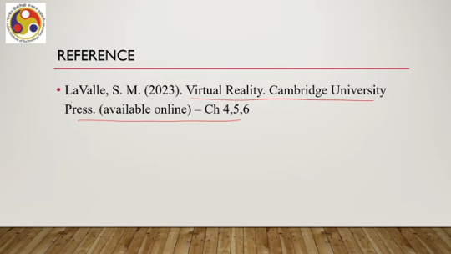
It will be very useful for further information. I hope you could follow the concepts and you could understand how our perception, visual perception works and how it relates to the design of extended reality systems, including the design of experience. So, looking forward to meeting you in the next lecture. Till then, thank you and goodbye.
Happy learning.

